Name: Braydon Spangler

1.1. Project Description

Our project idea is called AM I IN DANGER??? (working title), an application that combines a number of monitoring and analysis web services to determine how dangerous your current circumstances are, as well as the most dangerous elements around you. Examples of these elements include nearby crime data, chances of natural hazards in your area, and estimated nearby weather. The application does not take into account personal elements, such as mental disabilities.

The application will combine data from different elements, encrypt the data, and send it to the algorithm processor, which will decrypt the data and calculate your ‘danger score’. This danger score is a numerical value that estimates how much danger you are in; the higher the number, the more likely you are in danger. The danger score breakdown will process the majority of the application’s output, detailing what you are most in danger from and what precautions can be taken to stay safe.

1.2

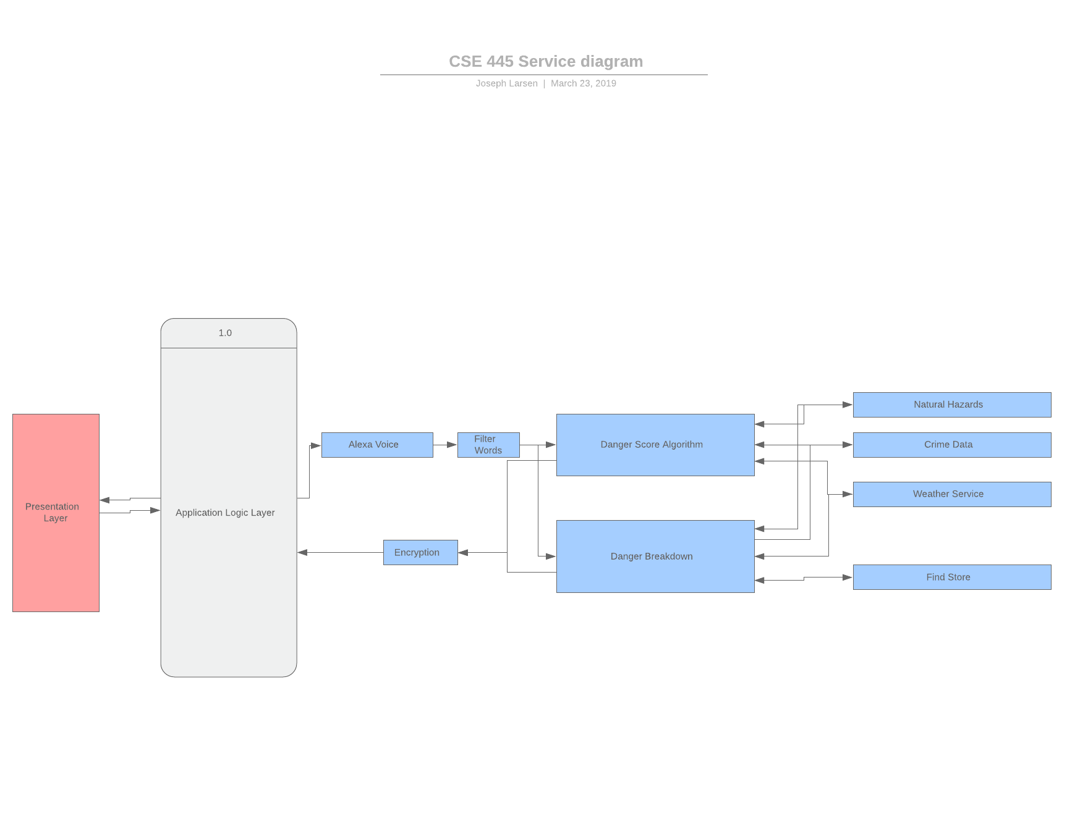

1.3

|  |  |  |  |  |
| --- | --- | --- | --- | --- |
| Service Directory: AM I IN DANGER??? | | | | |
| Name: Braydon Spangler | | | | |
| Member Name | Service Name w/ I/O | TryIt Link | Service Description | Planned Resources |
| Braydon Spangler | Weather Hazards  I: int lat, int long  O: int danger_index | N/a | Processes natural disaster likelihood in the given area into a numerical value, takes a latitude and longitude as input and a number reflecting the current natural disaster likelihood as output | Uses data from the given API: https://www.metaweather.com/api/location/search |
| Braydon Spangler | Filter Words  I: string input, string[] filterWords  O: string output | N/a | Originally meant to be used mainly for processing alexa voice command or managing other ambiguous input, should take a string as input, process and return an array of strings as output | All code will be personally written, a list of specific keywords will be used for processing |
| Braydon Spangler | Geolocator  I: string street_address, string city, string state  O: int lat, int long | N/a | Meant to enable lots of other services used in system. Takes user’s known street address and turns it into lattitude and longitude coordinates, which can then be used by other services for their input. | Uses data from given API endpoint: https://api.geocod.io/v1.3/ |

CSE446 Notes:

This project originally included 9 services, 3 per team member, which would all combine to provide multiple layers of danger, such as standard weather forecast, nearby crime index, etc. to give a detailed understanding of how much danger someone is in based on their home address. This has been condensed significantly since it will only be using my 3 services.